**Screenshot file**

**Step 1: Identify Jenkins Data to Backup**

1.1 Created EC2 instance

1.2 Installed Jenkins and able to open in the browser using port 8080.

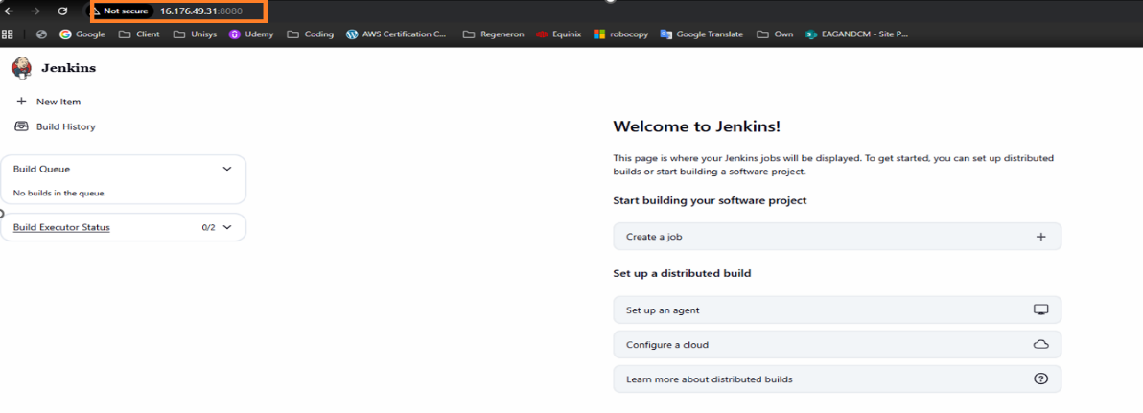

1.3 files and directories located in /var/lib/jenkins

**Step 2: Create an S3 Bucket for Backups**

* 1. Log in to AWS Management Console and create a bucket.

2.2 provide the s3 bucket name.

2.3 enable versioning and encryption

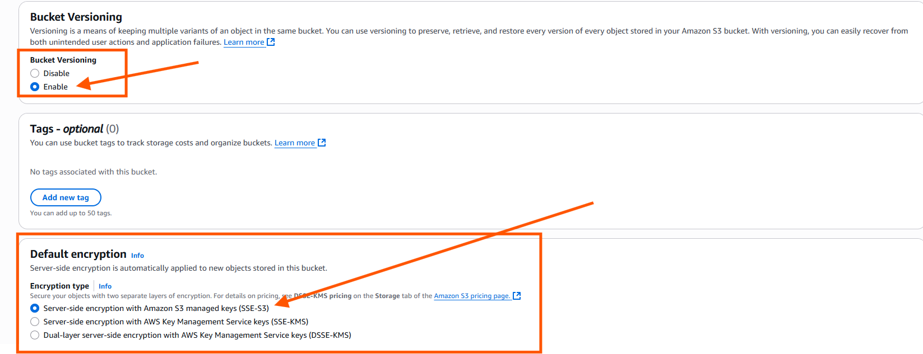

**Step 3: Configure IAM Role for Jenkins Backup**

3.1Go to IAM → Roles → Create.

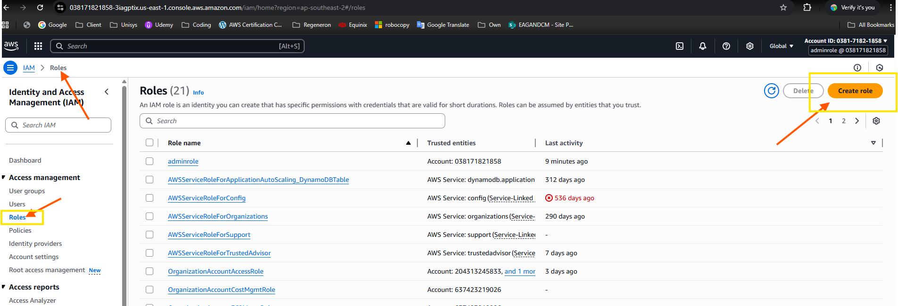

3.2 Select AWS service and select EC2

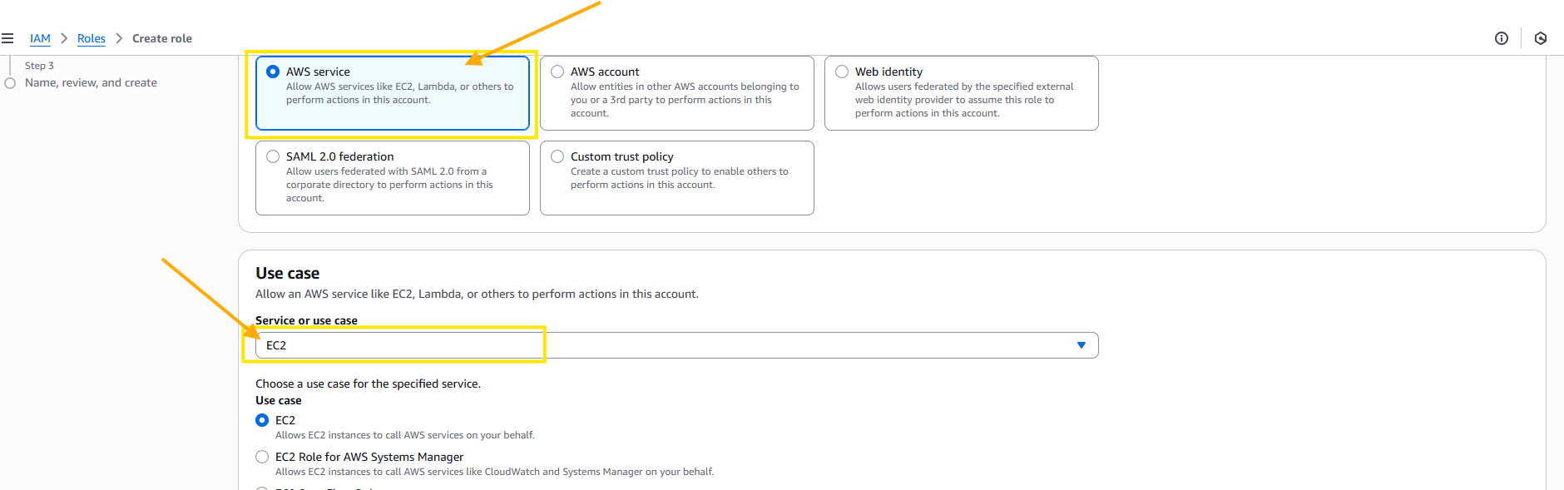

3.3 Attach AmazonS3fullaccess permission to EC2 service.

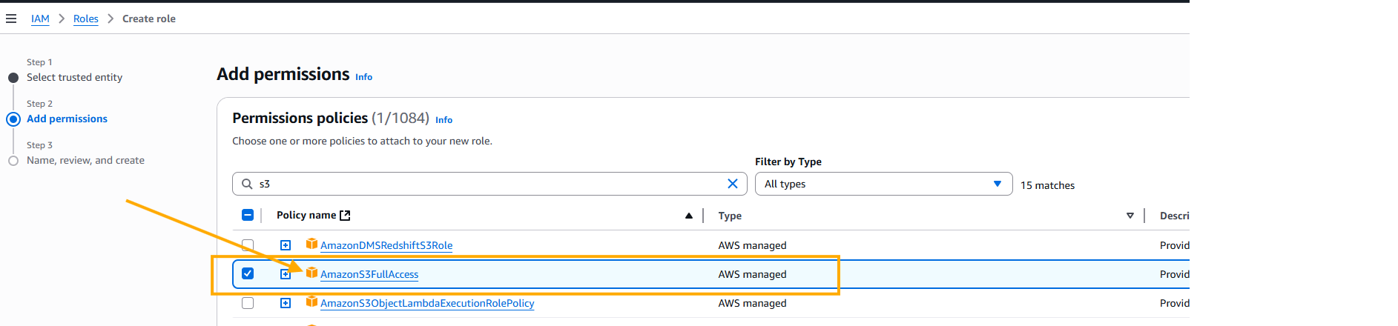

3.4 Enter a role name

3.5 Role “Jenkinsbackups” created below

3.6 Add the IAM role “Jenkinsbacks” with the EC2 instance.

**Step 4: Install AWS CLI on Jenkins Server**

4.1 Update the existing packages on Jenkins server.

4.2 Installed AWS CLI on the Jenkins server



**Step 5: Create Backup Script**

5.1 create a bash shell script to configure backup

5.2 change the permission to the bash shell script file as executable.

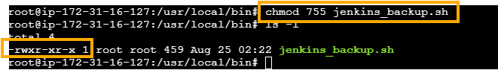

**Step 6: Automate Backups via Cron**

6.1 open the crantab and schedule the backup at 04:15AM UTC

**Step 7: Test Backup Script**

7.1 Check the backup completed as per schedule as per log



7.2 check the log file in S3 bucket

**Step 8: Restore Jenkins from S3**

* 1. Launch Jenkins server and install base Jenkins.

* 1. Make sure that AWS cli installed and able to see the S3 bucket.



* 1. Stop the Jenkins service to copy the backup file.

8.4 make sure that Jenkins service is stopped.

8.5 restore the backup file from the S3 bucket and start the Jenkins service.

